Our Work
Health
Page Banner on Health (Scrolling)
Message in all banners Healthcare Reach for All
Why Healthcare

In a vast country like India having population of more than 1.4 Bn, Healthcare access to all is a phenomenal challenge. Govt of India doing its bit by “Ayushman Bharat” initiative. Many Non-Profit Organizations also supporting Govt. directly/indirectly in this novel cause. Emyris Foundation also determined to play its part for the improvement of Healthcare facilities around its operational states.
While Ayushman Bharat primarily deals with secondary and tertiary care, there's an undercurrent emphasis on preventive health through its wellness centers. Emyris Foundation has initiatives aimed at preventive care and community health awareness campaigns , which could provide a structured framework for these initiatives, leveraging the existing infrastructure for broader outreach.
What We Do

Emyris Foundation promotes preventive care, which is often more cost-effective than treatment. This approach not only addresses immediate health needs but also invests in long-term health outcomes, potentially reducing the prevalence of chronic diseases through better management and education.
We aim to reach every doorstep of underserved communities in both rural and urban India.

Our Support

Telemedicine | Standalone Clinics | Health Camps

You can consult with healthcare providers from your home, reducing the need for travel, which is particularly beneficial for those with mobility issues, time constraints, or those living in remote areas. | These facilities are designed to provide essential outpatient services without the need for overnight stays, catering to diagnostics, minor treatments, and follow-up consultations, significantly improve healthcare access for remote populations, reducing travel time and costs. | Health camps often focus on preventive measures such as vaccinations, screenings for diseases like diabetes, hypertension, or cancer, and health education. This proactive approach can lead to early detection and management of conditions, potentially saving lives.

OUR FOCUS

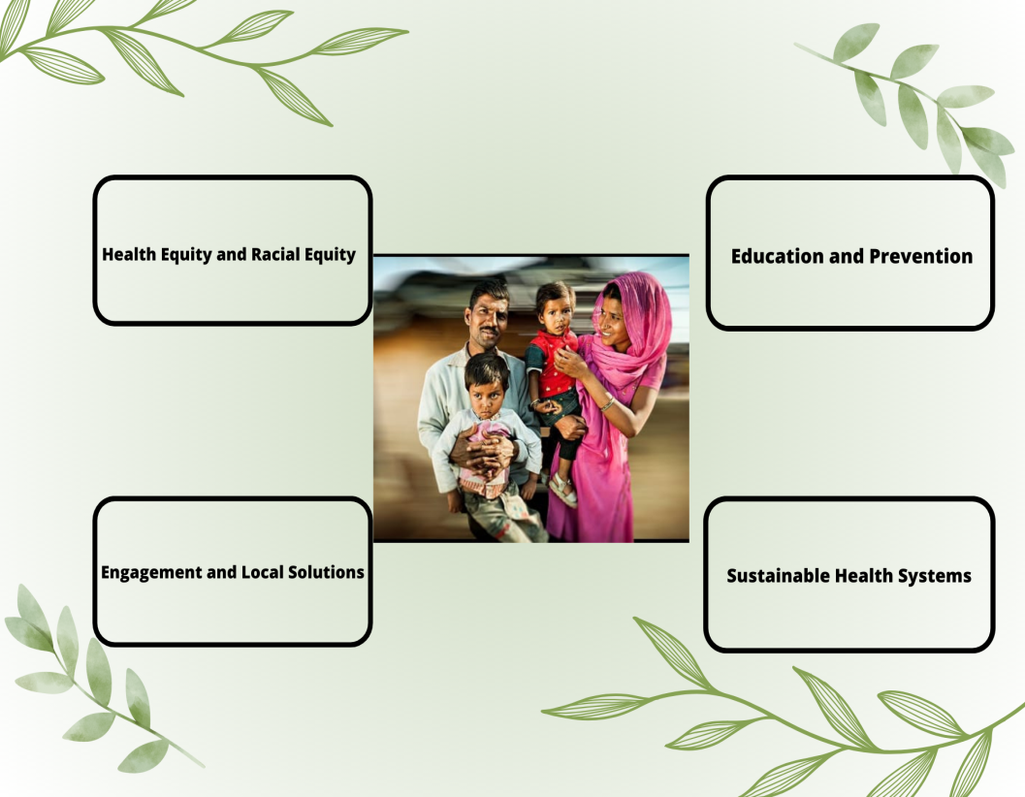
IMPACT 23-24
PHOTOGRAPHS AND MESSAGE WILL APPEAR HERE.

REACH & PRESENCE
ACTIVITIES DONE IN DIFFERENT AREAS WILL APPEAR WITH MESSAGE. Messagewill appear inside circle.

20 villeges&slums 3 states 2 projects 4 future projects

TOGETHER WE ARE GROWING
RANI
Suffering from and help she got message with read more

4 treated persons name with message. Below botton view all for more such details.
THEIR SUCCESS, OUR HAPPINESS

Youtube videos will appear here with scroll option.<>

